Year 5 Half-Term Project
Mission: Become a Space Expert!
What makes our Solar System so fascinating?
Over the half term holiday, we would like you to become a space expert and create a project to teach others about an aspect of space that interests you.
Choose Your Space Mission

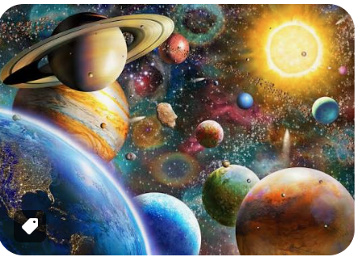
Choose ONE of the following:
Mission 1: Planet Explorer
Research a planet from our Solar System.
Include:
- Key facts
- Distance from the Sun
- Number of moons
- Temperature
- Interesting features
- Could humans live there?
Mission 2: Astronaut Academy
Research a famous astronaut.
Include:
- Biography
- Training they completed
- Space missions
- Achievements
- Interesting facts
Examples:
- Tim Peake / Helen Sharman / Mae Jemison / Neil Armstrong / Sally Ride
Mission 3: Space Technology
Investigate a spacecraft, rover, telescope or satellite.
Examples:
- James Webb Space Telescope
- Hubble Telescope
- International Space Station
- Perseverance Rover
- SpaceX Starship
Include:
- Purpose
- How it works
- Discoveries made
- Images or diagrams
Mission 4: Life on Another Planet
Design your own planet and explain how life might survive there.
Include:
- Climate
- Landscape
- Gravity
- Plants and animals
- Food chain
- Adaptations for survival
Your Final Product
Choose how to present your work:
- You could create a poster, a model, a PowerPoint, a booklet, a video, a museum-style display or a combination of several ideas – its up to you! USE YOUR IMAGINATIONA AND BE CREATIVE.
- PLEASE RETURN TO YOUR TEACHER BY 6th November 2026

